SIMATS ENGINEERING

CSA15 – CLOUD COMPUTING AND BIG DATA ANALYTICS

ASSIGNMENT 3 – CO3

OBE-Based Evidence Principle
Design a Cloud-Based Collaborative Solution
CO3: Implement cloud-based solutions using cloud storage, web APIs, and platform services for real-world applications.

Field | Details | Field | Details
Student Name | VIKRAM P | Register Number | 192511321
Department / Section | CSE | Academic Year / Semester | 2025/MS2
Faculty Name | DR.R.LATHA | Nature of Assignment | Individual
Duration | 1 Week | Total Marks | 50
Submission Date | 5/11/2026 | Evaluation Date

MARK SHEET (Rubric-based evaluation)
Task | Title | Max | Awarded | Evidence / evaluation focus
1 | Accessing Cloud Services through Different Methods | 6 |  | Access-method diagram; demonstration; screenshots; comparison
2 | Cloud Platforms and Web Applications | 7 |  | Two platforms; interaction diagram; app demonstration; evaluation
3 | Web APIs for Cloud Access | 7 |  | API design; executable client; two requests; responses
4 | Cloud Security and Network Access | 7 |  | Secure-access architecture; threats; authentication; mitigations
5 | Collaboration Using Cloud-Based Services | 6 |  | Shared workspace; permissions; edits; contribution evidence
6 | Integrated Cloud Access and Collaboration Mini Investigation | 7 |  | Scenario; architecture; prototype; two user tests; evaluation
7 | Day-4 Design Challenge: Cloud-Based Collaborative Solution | 10 |  | Two independent proposals; comparison; joint design; validation; defence
 | TOTAL | 50 |  | Percentage:

VERALL REMARKS

Student Signature | Faculty Signature | Program Director

MANDATORY SUBMISSION EVIDENCE CHECK

✓ = Present in documented answer; P = Partly present; ✗ = Missing / not satisfied
Task | Evidence expected | Status | Evaluator note
1 | Three access methods,  client–network–cloud diagram, demonstration and observations |  | Access-method classification and practical access screenshots to be checked.
2 | Two-platform comparison, interaction diagram and cloud web-app demonstration |  | Platform mapping, user-action sequence and local-versus-cloud evaluation to be checked.
3 | API flow, program, two request inputs, responses and execution evidence |  | Code, actual request/response outputs and analysis to be checked.
4 | Secure-access flow, four security considerations, threat and mitigation analysis |  | Authentication, authorization and secure-communication evidence to be checked.
5 | Shared workspace, permission settings, two collaborative activities and contributions |  | Verify shared editing, user roles, permissions and contribution screenshots.
6 | Integrated scenario, architecture, prototype, two user scenarios and results |  | Verify cloud access, collaboration workflow, tests and limitations.
7 | Two initial proposals, comparison record, joint design, tests and cross-defence |  | Verify independent proposals, joint decisions, observed results and both students’ understanding.

IMPLEMENTATION EVIDENCE CHAIN
Evidence item | Status | Observation
Cloud access methods |  | Browser, mobile and API access methods explained.
Cloud platforms |  | Two cloud platforms and their applications compared.
Cloud access  demonstration |  | Actual screenshots need verification.
Web API implementation |  | Program and execution outputs need verification.
Cloud security |  | Authentication, authorization and security measures explained.
Cloud collaboration |  | Shared workspace and editing evidence need verification.
Mini-project |  | Design included; practical testing needs verification.
Day-4 design challenge |  | Individual proposals, joint design and validation need verification.
Student contributions |  | Contributions of both students need confirmation.
Screenshots |  | Original execution screenshots required.

SUBMISSION CHECKLIST (Not Separately Marked)
Requirement | Status
All 7 questions answered | - Yes ☐ Partly ☐ No
Cloud access methods explained | - Yes ☐ Partly ☐ No

Cloud architecture diagrams included | - Yes ☐ Partly ☐ No
Two cloud platforms compared | - Yes ☐ Partly ☐ No
Web API program and testing completed | - Yes ☐ Partly ☐ No
Cloud security explained | - Yes ☐ Partly ☐ No
Cloud collaboration demonstrated | - Yes ☐ Partly ☐ No
Mini-project completed and tested | - Yes ☐ Partly ☐ No
Day-4 design challenge completed | - Yes ☐ Partly ☐ No
Student A and B contributions recorded | - Yes ☐ Partly ☐ No
Screenshots and practical evidence attached | - Yes ☐ Partly ☐ No
Viva recommended | - Yes ☐ No

CLOUD COMPUTING AND BIG DATA ANALYTICS ASSIGNMENT 3 – CO3
CO3: Implement cloud-based solutions using cloud storage, web APIs, and platform services for real-world applications.

Mode: Pair Work – 2 Students per Group
Duration: 1 Week Total Marks: 50

OBE-Based Evidence Principle
The assignment requires students to demonstrate measurable evidence of: Understand → Design → Implement → Demonstrate → Analyse → Evaluate
Both students must understand the complete assignment. Students should not simply divide questions between them. Individual responsibilities are assigned within each question so that the contribution and attainment of CO3 can be independently verified.

Q1 – Accessing Cloud Services through Different Methods 6 Marks
Shared Group Work
Together, the pair must:
- Identify different methods of accessing cloud services.
- Study browser-based/cloud console access.
- Study access through mobile applications.
- Study access through APIs.
- Identify the role of Internet/network connectivity.
- Select one suitable cloud service for demonstration.

Student A – Access Method Design
Student A must individually:
- Identify and classify at least three cloud access methods.
- Prepare a simple architecture/flow diagram showing:
Client → Network → Cloud Service
- Explain how a user accesses the selected cloud service.
- Identify the hardware/software requirements.
- Explain the role of the client and network.
- Justify which access method is most suitable for the selected application.

Student B – Practical Evidence
Student B must individually:
- Demonstrate access to a cloud service using one selected method.
- Record the steps/screenshots as evidence.
- Test the access using different devices or access methods where possible.
- Record observations such as accessibility, response, and usability.
- Identify one limitation encountered during access.
- Explain how the limitation can affect cloud usage.

Cross-Verification
Student A must be able to explain Student B's practical demonstration. Student B must be able to explain Student A's access architecture.
Evidence Expected: Architecture diagram + screenshots/observations + comparison.

Q2 – Cloud Platforms and Web Applications 7 Marks
Shared Group Work
Together:

- Select two cloud platforms/services.
- Identify the web applications available through them.
- Study how users interact with the applications.
- Identify the cloud resources/services supporting the application.
- Prepare a comparative observation.

Student A – Platform Analysis
Student A must individually:
- Identify the major components of the selected cloud platform.
- Explain how the platform supports web applications.
- Map the user request to the cloud service.
- Explain the role of the Internet, server/cloud infrastructure and application.
- Prepare a simple interaction diagram. Student B – Application Investigation Student B must individually:
- Select one real-world cloud-based web application.
- Demonstrate its major functions.
- Record the sequence of user actions.
- Identify where cloud access is involved.
- Collect screenshots/evidence of the demonstration.
- Analyse the benefits of using the cloud-based application.

Joint Evaluation
Together answer:
If the same application were installed and operated only on a local computer, what limitations might users experience compared with accessing it through the cloud? Evidence Expected: Platform/application mapping + demonstration evidence + evaluation.

Q3 – Web APIs for Cloud Access 7 Marks
Shared Group Work
Together:
- Study the concept of a Web API.
- Identify how APIs enable application-to-cloud communication.
- Select a simple publicly accessible API or cloud API.
- Develop a small program/client to send a request.
- Observe and record the response. Student A – API Design and Understanding Student A must individually:
- Explain the purpose of the selected API.
- Identify the request and response components.
- Represent the API communication using a flow diagram.
- Explain the role of:
  - Client
  - API request
  - Cloud/server
  - API response
- Explain how APIs enable programmatic cloud access.

Student B – Implementation and Evidence
Student B must individually:
- Implement a simple API request using Python or another suitable language.
- Execute the program.
- Record input/request and output/response.
- Test at least two different requests or inputs.
- Capture execution evidence.
- Analyse the observed results.

Joint Analysis

Together determine:

Why is API-based access useful when a large number of users/applications need to communicate with a cloud service automatically?
Evidence Expected: Program + execution screenshots + request/response evidence + analysis.

Q4 – Cloud Security and Network Access 7 Marks
Shared Group Work
Together:
- Identify security issues involved in accessing cloud services.
- Study authentication and authorization.
- Study secure network communication.
- Identify possible threats during cloud access.
- Prepare a secure cloud-access scenario.

Student B – Security Design
Student B must individually:
- Identify at least four security considerations for cloud access.
- Explain authentication and authorization.
- Explain the importance of secure communication.
- Design a secure access flow:
User → Authentication → Network → Cloud Service → Authorization → Resource
- Identify possible points of attack.
- Suggest suitable security measures. Student A – Security Investigation Student A must individually:
- Investigate a practical cloud-access security scenario.
- Demonstrate or document a suitable authentication mechanism where feasible.
- Compare secure and insecure access situations conceptually.
- Record observations.
- Explain how poor security practices can affect cloud users and data.

Joint Evaluation
Together answer:

If cloud access is available from anywhere through the Internet, what additional security measures are necessary compared with a local application?
Evidence Expected: Secure-access architecture + threat identification + mitigation analysis.

Q5 – Collaboration Using Cloud-Based Services 6 Marks
Shared Group Work
Together:
- Select a cloud collaboration platform/service.
- Create a shared document/folder/project space.
- Configure appropriate sharing permissions.
- Perform collaborative editing.
- Record the collaboration process. Student A – Collaboration Design Student A must individually:
- Identify the collaboration requirements.
- Design a suitable cloud collaboration workflow.
- Explain:
  - Sharing
  - Concurrent access
  - Version control
  - Permission management

- Identify the roles of different users.
- Justify the selected sharing permissions. Student B – Collaborative Implementation Student B must individually:
- Participate in the shared cloud workspace.
- Perform at least two collaborative activities.
- Record evidence of contribution.
- Demonstrate sharing/permission settings.
- Observe how changes made by users are reflected.
- Identify one collaboration issue and suggest a solution.

Cross-Understanding
Student B must explain:

How does cloud collaboration reduce the need to exchange multiple copies of the same file?
Student A must explain:

What problems can occur if incorrect sharing permissions are given?
Evidence Expected: Shared workspace + contribution evidence + permission screenshots
+ observations.

Q6 – Integrated Cloud Access and Collaboration Mini Investigation 7 Marks
Students must design a small real-world scenario that requires both cloud access and cloud collaboration.

Suggested Scenarios
Choose one:
- Cloud-based Student Project Management
- Online Student Attendance and Faculty Collaboration
- Cloud-Based Event Management
- Cloud-Based Assignment Submission and Evaluation
- Cloud-Based Hospital Appointment Coordination
- Cloud-Based Disaster Information Sharing
- Cloud-Based College Placement Coordination

Student A – System Design
Student A must individually:
  - Define the problem.
  - Identify users.
  - Identify cloud access methods.
  - Identify required cloud services.
  - Design the system architecture.
  - Explain how users access the system.
  - Explain how users collaborate. Student B – Evidence and Evaluation Student B must individually:
  - Develop a small prototype/mock-up/workflow where feasible.
  - Demonstrate at least one cloud access mechanism.
  - Demonstrate one collaboration mechanism.
  - Record screenshots/evidence.
  - Test the proposed solution using at least two user scenarios.
  - Analyse the results.
  - Identify limitations and possible improvements.

Joint Evaluation
Together answer:
How does combining cloud access and cloud collaboration improve the efficiency of the proposed system?

Q7 – DAY-4 DESIGN CHALLENGE

Design a Cloud-Based Collaborative Solution 10 Marks
This question must be solved collaboratively.
Neither student should independently prepare the complete solution and combine it later.

Stage 1 – Independent Design Proposal
Before discussing with each other:

Student A independently proposes:
  - Problem definition
  - Target users
  - Cloud access method
  - Required cloud services
  - Collaboration mechanism
  - Basic architecture

Student B independently proposes:
  - Problem definition
  - Target users
  - Cloud access method
  - Required cloud services
  - Collaboration mechanism
  - Basic architecture
Both initial proposals must be retained as evidence.

Stage 2 – Compare the Two Designs
Together discuss:
  - Where the designs agree
  - Where they differ
  - Strengths and weaknesses
  - Security concerns
  - Accessibility
  - Collaboration requirements
  - Missing components
  - Which ideas should be retained Prepare a Design Comparison Record.

Stage 3 – Joint Final Design Develop the final cloud-based solution. The final design must identify:
  - Problem
  - Users
  - Cloud access method
  - Network requirements
  - Cloud service/platform
  - Web application/API requirement
  - Collaboration mechanism
  - Authentication/security

  - Data/resource sharing
  - Complete system workflow Prepare an architecture such as:

Users → Client → Internet/Network → Cloud Platform → Application/API → Shared Resources

Stage 4 – Validation

Student A – Technical Validation

Student A must:
  - Explain the selected cloud access method.
  - Justify the platform/service selection.
  - Explain the system architecture.
  - Explain how API/web access is used, if applicable.
  - Analyse the suitability of the design.

Student B – Experimental Validation

Student B must:
  - Design test cases.
  - Demonstrate the solution/workflow.
  - Test different users/access conditions.
  - Record observations.
  - Present screenshots or other evidence.
  - Compare expected and observed behaviour.

Stage 5 – Cross-Defence

Student A must explain:

What experimental evidence supports the group's cloud design?

Student B must explain:

Why was the selected cloud access and collaboration approach chosen?

Stage 6 – Joint Evaluation

Together determine:
  - Benefits of the proposed cloud solution
  - Access-related limitations
  - Collaboration benefits
  - Security risks
  - Scalability considerations
  - Possible improvements
  - Situations where the proposed approach may not be appropriate
Final Question

What characteristics should a system designer consider before selecting cloud-based access and collaboration for a real-world application?

CONTRIBUTION RECORD

Each pair must include the following table at the end of the submission.
Question | Student A – Primary Contribution | Student B – Primary Contribution | Joint Work
Q1
Q2
Q3
Q4
Q5
Q6
Q7
The contribution record must reflect the actual work completed.
Primary contribution does not mean exclusive responsibility. Both students are accountable for the complete assignment.

INDIVIDUAL VERIFICATION – OBE EVIDENCE
Faculty may select any question or component for individual verification. Each student must be able to:
  - Explain the cloud access method.
  - Explain the role of client, network and cloud service.
  - Explain web application/API access.
  - Explain security considerations.
  - Demonstrate cloud collaboration.
  - Interpret experimental evidence.
  - Justify design decisions.
  - Respond to a modified requirement or scenario. A student should not answer:

“My partner did this section.”
Understanding of the complete submitted work is mandatory.

RECOMMENDED FACULTY VERIFICATION MODEL – VIVA
For each student, conduct a brief 4–5 minute verification. Question 1 – Primary Responsibility
Ask one technical question from the component for which the student had primary responsibility.

Question 2 – Partner's Responsibility
Ask one question from a component primarily completed by the partner.

Question 3 – Transfer Question
Modify a condition and ask the student to reason about the consequence.

Examples:
“If Internet connectivity becomes unreliable, how would it affect cloud access?”
“If a shared cloud document is given editing permission to everyone, what problems could occur?”
“If the API becomes unavailable, how would your application behave?”
“If a user is authenticated but does not have permission to access a resource, what should happen?”

This provides individual evidence of CO3 attainment without requiring two completely separate assignments.

OBE Evidence Mapping
CO3 Component | Assignment Evidence
Build methods to access cloud | Q1, Q2, Q3
Access through platforms/web applications | Q2
Programmatic/API-based access | Q3
Secure cloud access | Q4
Collaboration within cloud | Q5
Apply cloud access + collaboration | Q6
Design and evaluate a cloud solution | Q7
Individual attainment | Viva + contribution record
Practical evidence | Screenshots, programs, observations, test results
Higher-order learning | Design, analysis, evaluation and transfer questions

Q1 – Accessing Cloud Services through Different Methods (6 Marks)

Shared Group Work
Cloud access means using remote storage, computing and software services over a network instead of local hardware. The user only needs a client device and Internet connectivity; the provider manages servers, storage and security. Selected service for demonstration: Google Drive (cloud storage and file-sharing service).
Method | How it works | Example with Google Drive
Browser / cloud console | User opens a web URL, logs in, and uses the service through HTML pages over HTTPS. | drive.google.com in Chrome; Google Cloud Console
Mobile application | A dedicated app on Android/iOS connects to the cloud through Wi-Fi or mobile data; supports camera upload, offline cache, push notifications. | Google Drive app on Android/iOS
API / programmatic access | A program sends HTTP requests (REST) with an access token and receives JSON; used for automation and integration. | Google Drive REST API v3 (list, upload, share files)

Role of Internet/network: It carries requests and responses between client and cloud. Bandwidth decides upload/download speed, latency decides responsiveness, and HTTPS/TLS protects data in transit. Without connectivity, only cached/offline copies are usable.

Student A – Access Method Design
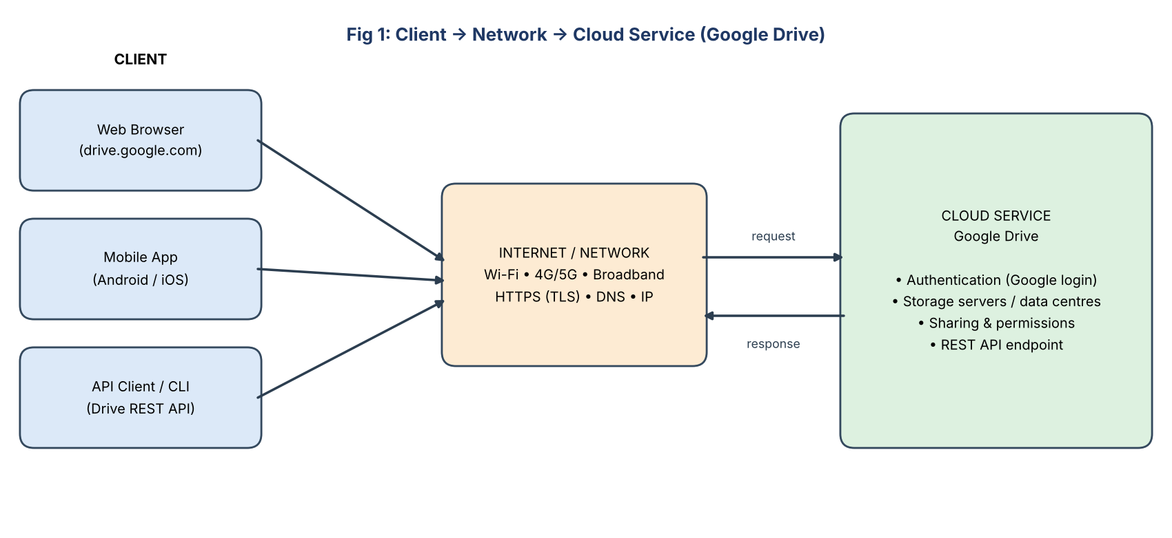
Fig 1: Client → Network → Cloud Service architecture

How a user accesses Google Drive
- User opens the browser or mobile app on the client device.
- The device resolves drive.google.com through DNS and opens a secure HTTPS (TLS) connection over the network.
- User signs in with Google account (password + optional 2-step verification); the cloud issues a session/access token.
- The request (view, upload, share) goes to Google's front-end servers, which check the token and permissions.
- Google's storage servers process the request and return the response (file list, upload status), which the client displays.

Hardware / software requirements
Method | Hardware | Software
Browser | PC/laptop/tablet, 2 GB+ RAM | Modern browser (Chrome, Edge, Firefox), Google account
Mobile app | Smartphone with Android 8+/iOS 15+ | Drive app, Google account, mobile data/Wi-Fi
API | Any computer with network | Python 3, requests library, API key/OAuth token

Role of the client: provides user interface, sends requests, stores tokens/cache and displays results (thin client – heavy processing is on the cloud). Role of the network: transports data securely, determines speed and availability.
Most suitable method: For file storage and sharing by students, the browser/mobile app is most suitable – no installation, platform independent, easy sign-in and instant sharing. API access suits automation (e.g., bulk upload by a program) but needs programming knowledge.

Student B – Practical Evidence
Demonstration (browser method) – steps:
- Open Chrome and go to drive.google.com; sign in with the Google account.
- Click New → Folder; name it “CO3_Assignment”.
- Upload a file (New → File upload) and observe the progress indicator.
- Right-click the file → Share to check access; open the same file on a mobile phone using the Drive app.
- Open the same account from a second device/browser to confirm files are synchronised.
Observation | Browser (laptop) | Mobile app | API client
Accessibility | Any device with browser | Anywhere, one tap | Needs code + token
Response speed | Fast on Wi-Fi | Fast; slower on 4G | Fast; depends on server
Usability | Rich UI, drag & drop | Simple, touch-based | Low (technical)
Offline use | Limited (offline mode) | Offline files supported | None

Limitation encountered: Upload slowed down / failed when the Wi-Fi signal was weak (dependency on Internet connectivity). Effect on cloud usage: users cannot reach or share files on time, large uploads must restart, and real-time collaboration stops. Mitigation: offline mode, stable network, resumable uploads.
Cross-verification: Student A can explain B’s steps (login → folder → upload → multi-device check) and Student B can explain A’s Client → Network → Cloud flow.

Q2 – Cloud Platforms and Web Applications (7 Marks)

Shared Group Work
Item | Platform 1: Google Cloud / Workspace | Platform 2: Microsoft Azure / Microsoft 365
Web applications | Gmail, Google Docs, Sheets, Drive, Meet | Outlook Web, Word/Excel Online, OneDrive, Teams
Supporting cloud resources | Compute Engine, Cloud Storage, Cloud SQL, load balancer, IAM | Azure VMs, Blob Storage, Azure SQL, Front Door, Azure AD
User interaction | Browser/mobile; Google sign-in; real-time co-editing | Browser/desktop/mobile; Microsoft sign-in; co-authoring
Service model | SaaS (Workspace) + IaaS/PaaS (Cloud) | SaaS (M365) + IaaS/PaaS (Azure)

Student A – Platform Analysis
Major components of a cloud platform: (1) Compute – virtual machines/containers/serverless; (2) Storage – object, file, block; (3) Database – SQL/NoSQL; (4) Networking – load balancer, CDN, firewall; (5) Identity & Access Management; (6) Monitoring and management tools.
How the platform supports web applications: The provider hosts the application on scalable servers, stores user data in managed storage/databases, balances load among many servers, secures access through IAM, and makes the application reachable through a URL from any device.
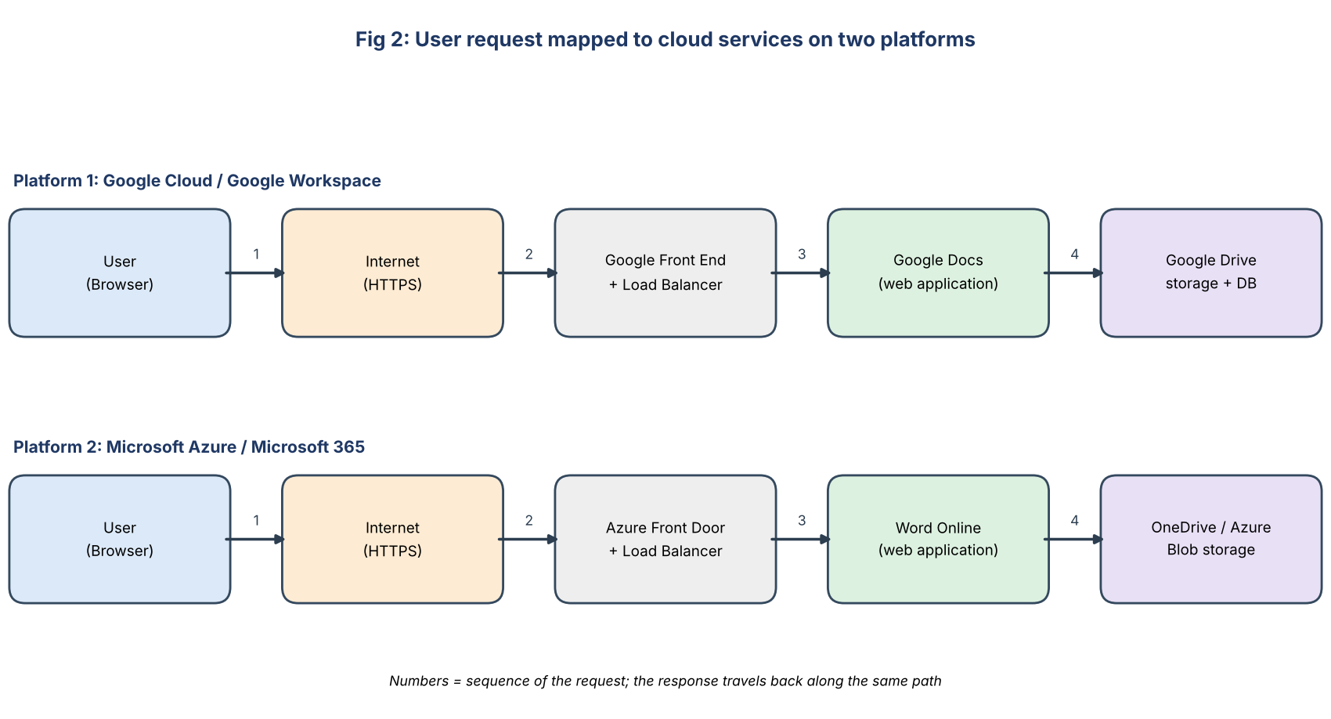
Fig 2: Interaction diagram – user request mapped to cloud services
Step | Mapping of user request to cloud service
1. User types URL / clicks Docs | Browser (client) creates an HTTPS request
2. Internet | Routes the request via DNS and ISP to the nearest cloud data centre
3. Front end / load balancer | Authenticates, picks a free server (scalability, availability)
4. Web application server | Runs Docs/Word Online logic; processes edit/save
5. Storage / database | Document is stored, versioned and replicated; response returned to browser

Role of Internet: connectivity between user and cloud. Role of cloud infrastructure: compute, storage, security, scaling. Role of application: business logic and user interface (document editing).

Student B – Application Investigation
Selected application: Google Docs (cloud-based word processor).
Major functions demonstrated: create document, type/format text, share with others, real-time co-editing, comments, version history, download as PDF/Word, auto-save.
No. | User action | Where cloud access is involved
1 | Sign in at docs.google.com | Authentication on Google servers
2 | Create new blank document | Document object created in cloud storage
3 | Type text; observe “Saving…”/“Saved to Drive” | Auto-save to cloud every few seconds
4 | Share with partner (Editor role) | Cloud permission list updated
5 | Open from mobile; see same content | Same cloud copy accessed from another device
6 | File → Version history | Cloud keeps earlier versions
7 | Download as PDF | Server converts and sends file
Benefits: access from anywhere/any device; no installation or manual saving; automatic backup and version history; real-time collaboration; free/low cost; automatic updates; scalable storage.

Joint Evaluation – Local installation vs Cloud
Aspect | Application only on local computer | Cloud access
Access | Only on that computer | Any device, anywhere
Collaboration | Files e-mailed, multiple copies, conflicts | Real-time shared editing, one copy
Backup / loss | Lost if disk fails or device stolen | Automatic replication and backup
Updates | Manual installation, licence cost | Automatic, always latest version
Storage / performance | Limited by local disk and hardware | Elastic, scalable resources
Internet dependency | Works offline | Needs Internet (offline mode limited)

Q3 – Web APIs for Cloud Access (7 Marks)

Shared Group Work
A Web API is an interface that lets one application communicate with another over HTTP using defined requests and responses (usually REST with JSON). Applications use APIs to send commands to a cloud service (read, create, update, delete data) without a human using a browser. Selected API: JSONPlaceholder (free public REST API hosted in the cloud) – endpoint https://jsonplaceholder.typicode.com/posts/{id}.

Student A – API Design and Understanding
Purpose of the API: provides sample “post” data (id, title, body, userId) so that developers can practise sending requests and processing responses, just like a real cloud API.
Component | Details
Request | Method: GET; URL: /posts/1; Headers: Accept: application/json; Body: none (GET)
Response | Status code: 200 OK; Headers: Content-Type: application/json; Body: JSON object {userId, id, title, body}
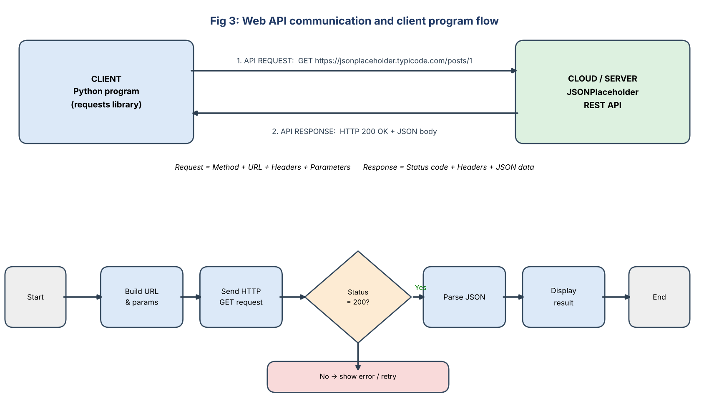
Fig 3: API communication flow and client-program flowchart
Role | Explanation
Client | Python program that builds and sends the request and processes the result
API request | Structured HTTP message asking the cloud for a resource
Cloud / server | Receives request, validates it, fetches data, builds reply
API response | Status code + JSON data returned to the client

How APIs enable programmatic cloud access: the same operations a user does in a browser can be done by code – automatically, repeatedly and at scale – using standard HTTP methods (GET, POST, PUT, DELETE), authentication tokens and JSON data.

Student B – Implementation and Evidence
Python program (api_client.py):
import requests

BASE_URL = "https://jsonplaceholder.typicode.com/posts"

def get_post(post_id):
url = f"{BASE_URL}/{post_id}"
print(f"\nREQUEST : GET {url}")
try:
r = requests.get(url, headers={"Accept": "application/json"}, timeout=10)
print("STATUS :", r.status_code)
if r.status_code == 200:
data = r.json()
print("userId :", data["userId"])
print("id :", data["id"])
print("title :", data["title"])
else:
print("ERROR : resource not found / request failed")
except requests.exceptions.RequestException as e:
print("Network error:", e)

# Test inputs
for pid in (1, 2, 9999):
get_post(pid)

Execution: run with python api_client.py (install library using pip install requests). Three inputs were tested: two valid and one invalid.
Test | Request input | Status | Response (key fields)
1 | GET /posts/1 | 200 OK | userId: 1, id: 1, title: “sunt aut facere repellat provident occaecati excepturi optio reprehenderit”
2 | GET /posts/2 | 200 OK | userId: 1, id: 2, title: “qui est esse”
3 | GET /posts/9999 (invalid) | 404 Not Found | Empty JSON {} – program prints error message
Analysis of results: Valid IDs returned status 200 with JSON data of the same structure, showing the API is consistent and machine-readable. An invalid ID returned 404, proving the server validates requests and that client programs must handle error codes. Response arrived within a second, showing low overhead of API access compared with manual browsing.

Joint Analysis – Why API access is useful for many users/applications
- Automation: thousands of programs can call the cloud without human interaction.
- Standardisation: common HTTP/JSON format works with any language and platform.
- Scalability: the cloud handles many concurrent requests using load balancing and elastic resources.
- Integration: different applications (mobile app, website, IoT) share the same cloud data.

Q4 – Cloud Security and Network Access (7 Marks)

Shared Group Work
Because cloud services are reached over the public Internet, they face risks such as stolen credentials, interception of data, unauthorised access and data leaks. The scenario chosen: a student accessing a shared Google Drive project folder from a college or public Wi-Fi network. Security rests on: authentication (who are you?), authorization (what are you allowed to do?), and secure communication (can anyone read or alter the data in transit?).

Student B – Security Design

Four (or more) security considerations
Consideration | Explanation
1. Identity & authentication | Verify the user with strong password + multi-factor authentication (OTP)
2. Authorization / access control | Give only needed permissions (least privilege, role-based access)
3. Data protection / encryption | Encrypt data in transit (TLS) and at rest (AES-256)
4. Network security | Firewall, VPN, secure Wi-Fi, DDoS protection
5. Monitoring & logging | Audit logs, alerts on unusual logins
6. Backup & compliance | Regular backup, data-privacy laws, retention policy

Authentication proves the identity of the user (e.g., Google login with password and OTP). Authorization decides what the authenticated user may do (viewer, commenter, editor, owner). A user may be authenticated but still be denied access to a resource when authorization fails. Secure communication (HTTPS/TLS) encrypts traffic so that attackers on the network cannot read or modify passwords and files, and certificates confirm the server is genuine.
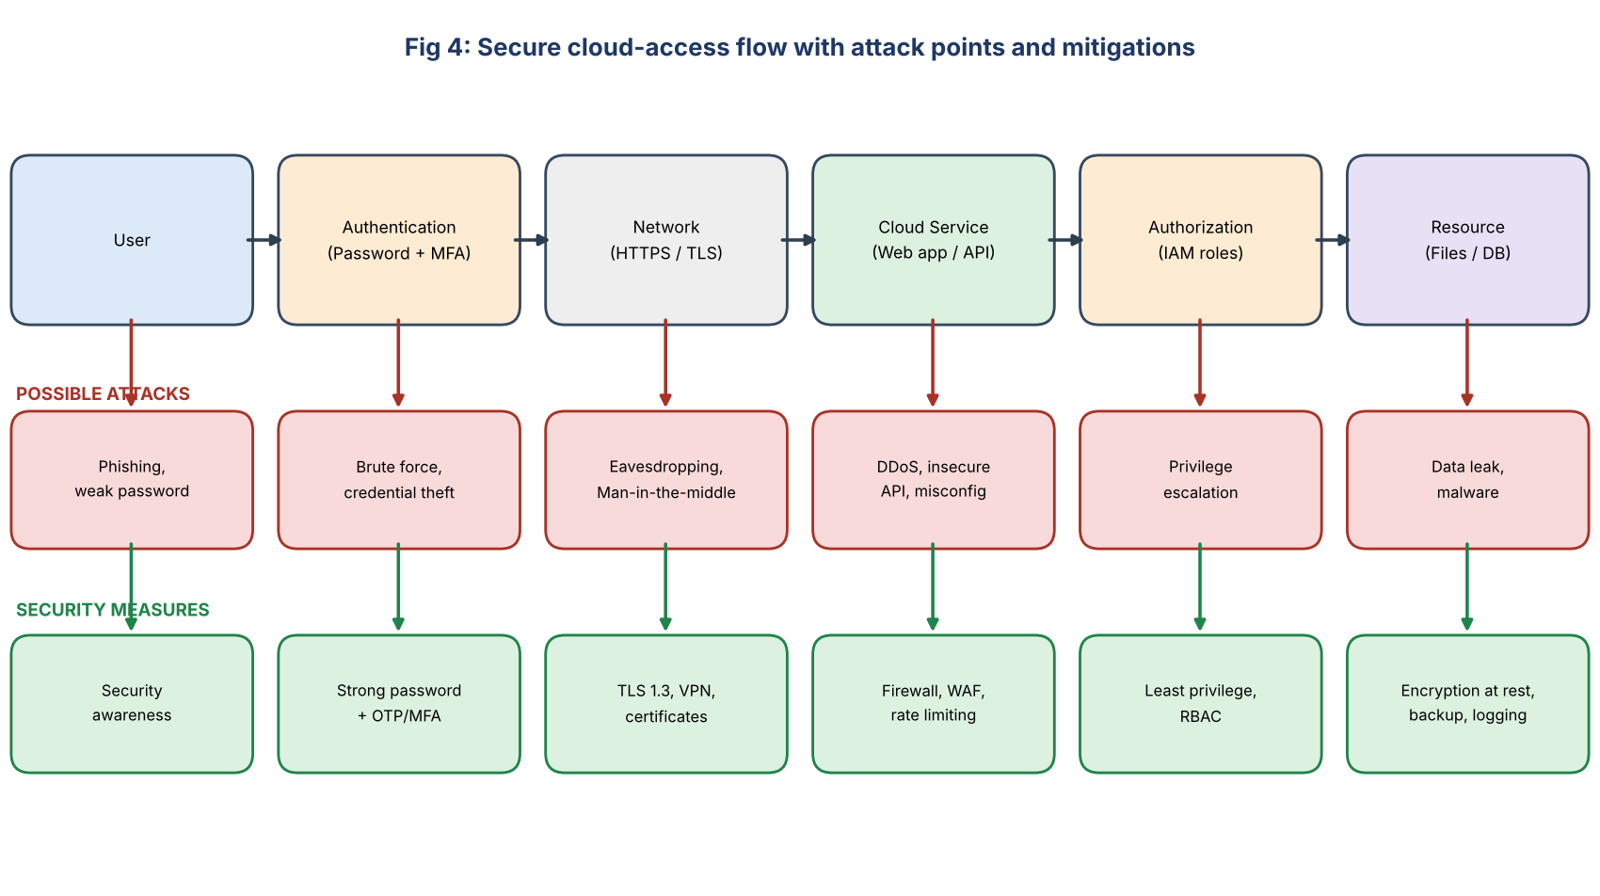
Fig 4: Secure access flow User → Authentication → Network → Cloud Service → Authorization → Resource
Point of attack | Threat | Mitigation
User | Phishing, weak/reused password | Awareness training, password manager
Authentication | Brute-force, stolen credentials | MFA, account lockout, CAPTCHA
Network | Eavesdropping, man-in-the-middle | HTTPS/TLS, VPN, certificate validation
Cloud service | DDoS, insecure API, misconfiguration | WAF, rate limiting, API keys/OAuth, security reviews
Authorization | Privilege escalation, over-sharing | Least privilege, RBAC, periodic access review
Resource | Data leak, ransomware | Encryption, backup, audit logs, DLP

Student A – Security Investigation
Scenario investigated: logging in to Google account from a new device. Authentication mechanism documented: 2-Step Verification – after entering password, Google sends a one-time prompt/OTP to the registered phone; access is granted only after the second factor is verified. (Steps: Google Account → Security → 2-Step Verification → Turn on; test sign-in from another browser.)
Aspect | Insecure access | Secure access
Protocol | HTTP – data in plain text | HTTPS – encrypted with TLS
Login | Single weak password | Strong password + MFA
Network | Open public Wi-Fi without VPN | Trusted network / VPN
Sharing | “Anyone with link can edit” | Specific users, least privilege
Result | Account takeover, data theft | Data confidentiality & integrity kept

Observation: the browser shows a padlock for HTTPS sites and warns for HTTP; MFA blocked the sign-in attempt from an unknown device until the OTP was entered. Effect of poor practices: stolen accounts, leaked/modified/deleted files, identity misuse, financial or reputational loss, loss of privacy and legal penalties for organisations.

Joint Evaluation – Extra measures needed compared with a local application
- Strong authentication (MFA) because the service is exposed to the whole Internet, not just a local network.
- Mandatory encryption in transit and at rest – data travels over networks not owned by the user.
- Fine-grained authorization (RBAC) and regular permission reviews for many remote users.
- Network protection: firewalls, WAF, DDoS defence, VPN on untrusted Wi-Fi.
- Continuous monitoring, audit logs and alerts for unusual logins from other locations.
- Secure API access (tokens, rate limits) and regular backups with a recovery plan.
- Shared-responsibility awareness – the provider secures infrastructure; the user secures accounts, data and settings.

Q5 – Collaboration Using Cloud-Based Services (6 Marks)

Shared Group Work
Platform selected: Google Drive + Google Docs. Shared space: folder “CO3_Team_Project” containing the document “Cloud_Report”. Both students were added by e-mail; the faculty member was added as Viewer/Commenter. Collaborative editing was done at the same time and the process was recorded using screenshots.

Student A – Collaboration Design
Requirement | Description
Shared access | All team members work on one copy of the document
Simultaneous editing | Two or more users edit at the same time
Change tracking | Know who changed what and when; restore old versions
Controlled permissions | Only authorised persons may edit or share
Communication | Comments and suggestions inside the document
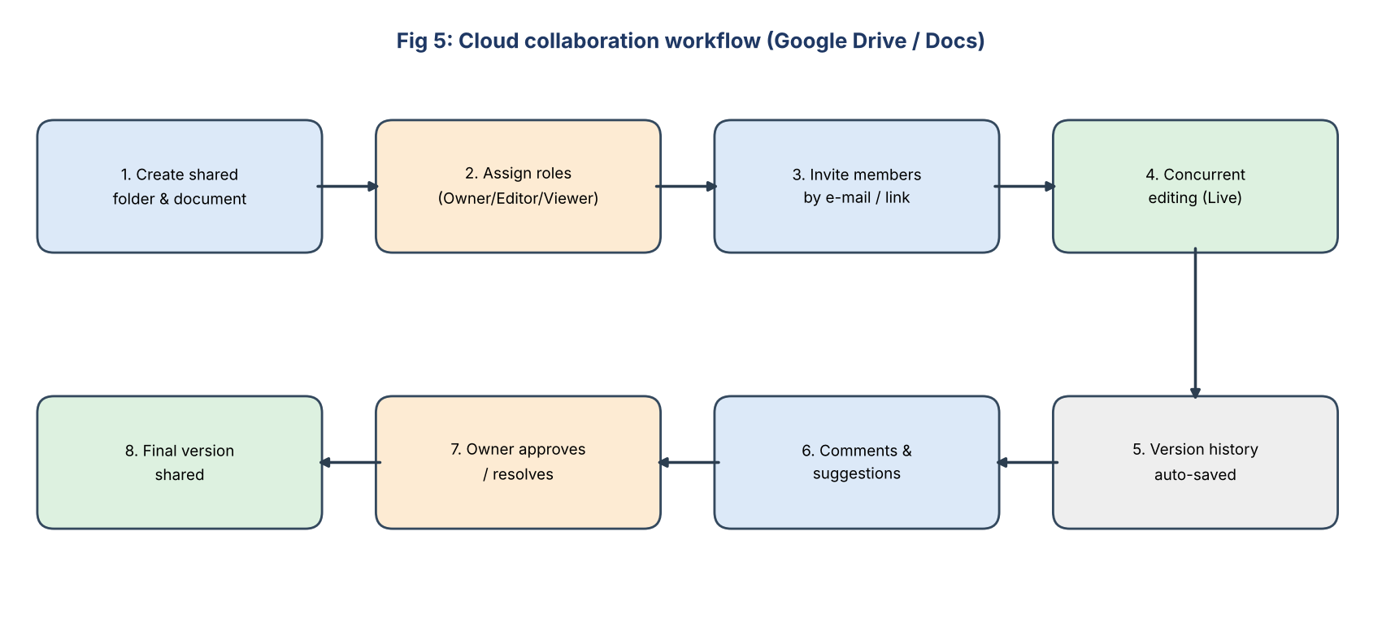
Fig 5: Cloud collaboration workflow
Concept | Explanation
Sharing | Owner shares folder/file by invitation (e-mail) or link; access is stored in the cloud permission list
Concurrent access | Several users edit simultaneously; the cloud merges changes in real time and shows each user’s cursor/colour
Version control | Automatic version history stores earlier versions with time and author; any version can be restored or named
Permission management | Roles: Viewer, Commenter, Editor, Owner; owner can change/remove access any time and block downloads

User | Role / permission | Justification
Student A (owner) | Owner | Creates structure, manages sharing
Student B | Editor | Needs to write and modify content
Faculty | Commenter / Viewer | Reviews and gives feedback without changing content
Others | No access (restricted) | Protects confidentiality (least privilege)

Student B – Collaborative Implementation
Collaborative activities performed: (1) Student B wrote the “Introduction” section while Student A edited “Conclusion” at the same time; (2) Student B added comments/suggestions on Student A’s paragraph and A accepted them; (3) a file was uploaded to the shared folder and renamed by B.
Permission settings demonstrated: Share → add people → select Editor/Viewer/Commenter; General access → Restricted; Settings: “Editors can change permissions” turned off. Observation: changes appeared on the other user’s screen within seconds, with the editor’s name and colour displayed; version history listed every change with timestamp.
Issue identified: two users edited the same sentence at the same time, creating conflicting/overwritten text. Solution: divide sections among members, use “Suggesting” mode, review in version history and restore the right version, and let the owner approve final changes.

Cross-Understanding
Student B – How does cloud collaboration reduce multiple copies? Everyone opens the same file stored in the cloud through a link instead of e-mailing separate copies. All edits are saved to one master copy, so there is no confusion about the “latest version”, no merging of several files, less storage and a full history of changes.
Student A – Problems from incorrect permissions: giving edit rights to everyone can lead to accidental or malicious deletion/changes; “anyone with the link” may leak confidential data; viewers wrongly given edit/share rights can pass access to outsiders; too few permissions block work and delay the project; loss of data integrity and accountability.

Q6 – Integrated Cloud Access and Collaboration Mini Investigation (7 Marks)
Selected scenario: Cloud-Based Student Project Management

Student A – System Design
Problem definition: Student project teams share files by WhatsApp/e-mail/pen drives, leading to multiple versions, missed deadlines, lost files, no clear task tracking and difficulty for faculty to monitor progress. A cloud-based system is required for storing, sharing, tracking and reviewing project work.
Users | Role
Student team members | Create content, upload files, update tasks
Team leader | Allocates tasks, manages sharing
Faculty guide | Reviews, comments, evaluates (view/comment only)
Department coordinator (optional) | Monitors all projects (view only)

Item | Choice
Cloud access methods | Browser (laptop/lab PC), mobile app (on the go), API/script (optional automatic report export)
Required cloud services | Google Sign-in (identity), Google Drive (storage), Docs/Sheets/Slides (editing), Sheets task tracker, Calendar (deadlines), Meet/Chat (communication)
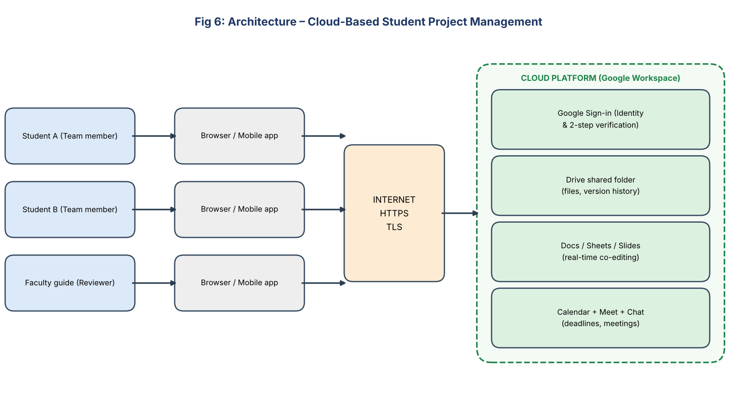
Fig 6: System architecture – Cloud-Based Student Project Management
How users access the system: each user signs in with a Google account (with 2-step verification) through browser or mobile app over HTTPS; the identity service checks credentials, and Drive applies the folder permissions (Team: Editor, Faculty: Commenter).
How users collaborate: team members co-edit documents in real time, record tasks and status in a shared Google Sheet, comment on each other’s work, schedule meetings in Calendar/Meet, and the faculty gives feedback through comments; version history tracks every change.

Student B – Evidence and Evaluation
Prototype built: Drive folder “Project_Mgmt_Prototype” with subfolders (Documents, Code, Reports) + Google Sheet “Task Tracker” (columns: Task, Owner, Deadline, Status) + shared Doc “Project_Report”.
Cloud access mechanism demonstrated: login to Drive through browser, then the same account opened on the mobile app. Collaboration mechanism demonstrated: simultaneous editing of the Task Tracker and Project_Report by two users with comments from the faculty.
Scenario | Test action | Expected result | Observed result
1. Team member (Editor) | Update task status and edit report from mobile | Change saved and visible to all | Change reflected in a few seconds – Pass
2. Faculty (Commenter) | Add comment; try to edit text | Comment allowed; edit blocked | Comment added; edit option disabled – Pass
3. Outsider (no access) | Open folder link | Access denied | “You need access” page – Pass

Analysis: the system met the requirements: single copy of files, real-time updates, role-based control, access from multiple devices. Limitations: depends on Internet; limited offline editing; no built-in advanced project features (Gantt charts, automated alerts); storage quota of free accounts; privacy depends on correct permission settings. Improvements: use Google Apps Script/API for automatic deadline reminders, add dashboards, use institutional accounts with enforced MFA, enable offline mode, schedule regular backups.

Joint Evaluation
Cloud access lets every member and the faculty reach the project from anywhere, on any device, at any time; cloud collaboration ensures they all work on one shared, version-controlled copy. Combined, they remove file exchange and version confusion, give real-time visibility of progress, reduce delays and rework, and make the review process faster and more transparent – improving overall efficiency, accountability and quality of the project.

Q7 – Day-4 Design Challenge: Cloud-Based Collaborative Solution (10 Marks)

Stage 1 – Independent Design Proposals (retained as evidence)
Element | Student A – Proposal | Student B – Proposal
Problem | Manual assignment submission through paper/e-mail causes loss, late submissions and slow evaluation | Faculty cannot easily collect, review and return feedback on student work in one place
Target users | Students and faculty | Students, faculty and department admin
Cloud access method | Web browser through a college portal | Mobile app + browser (Google Classroom style)
Required cloud services | Cloud storage, web hosting, database | Google Drive, Sheets, Cloud Functions/API for notifications
Collaboration mechanism | Shared folder per class; faculty comments on files | Shared Docs for group assignments with live co-editing and comments
Basic architecture | Student → Browser → Internet → Web server → Database/Storage | Student/Faculty → Mobile/Browser → Internet → Drive + API → Sheets

Stage 2 – Design Comparison Record
Aspect | Discussion
Where designs agree | Same problem (assignment handling); both use cloud storage, browser access, HTTPS, faculty comments
Where they differ | A: web portal with own database; B: mobile app, Drive shared docs and notification API
Strengths | A: central control, custom workflow, deadline validation. B: easy mobile access, built-in real-time collaboration, little development effort
Weaknesses | A: no mobile support, more development/maintenance, no group co-editing. B: less control over rules (deadline/file type), depends on third-party platform
Security concerns | A: needs own login system and server hardening. B: needs correct sharing permissions to avoid exposure
Accessibility | A: only browser. B: browser + mobile – better
Collaboration needs | Group assignments need co-editing (from B); plagiarism/ deadline checks need validation (from A)
Missing components | Authentication/MFA, role-based authorization, notifications, audit logs, backup
Ideas retained | A’s portal with validation + B’s mobile access, Drive shared folders, co-editing and notification API

Stage 3 – Joint Final Design
Item | Final decision
Problem | Paper/e-mail assignment submission is slow, error-prone and hard to evaluate and track
Users | Students (submit, view marks), Faculty (review, grade, comment), Admin (manage classes)
Cloud access method | Browser and mobile app (primary); REST API for portal–Drive integration
Network requirements | Reliable Internet (Wi-Fi/4G), HTTPS/TLS, min. 2 Mbps for uploads, DNS
Cloud service / platform | Google Workspace (Drive, Docs, Sheets, Chat) + Google Cloud (Cloud Run for portal/API)
Web application / API | Web portal for login, upload, status; REST API validates file type, size and deadline, stores to Drive, logs in Sheets/DB, sends notification
Collaboration mechanism | Shared class folders, Docs live co-editing for group work, faculty inline comments, version history
Authentication / security | Google Sign-in with MFA, RBAC (Student/Faculty/Admin), TLS, encryption at rest, audit logs, backup
Data / resource sharing | Student folder: student = Editor, faculty = Editor/Commenter; others no access; marks sheet = student view-only
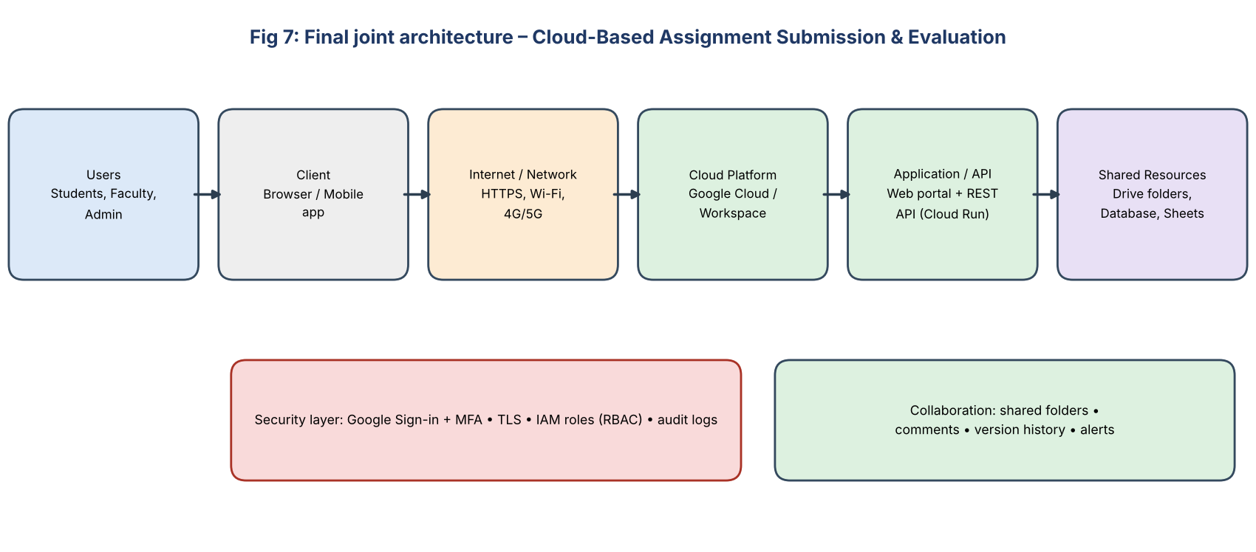
Fig 7: Users → Client → Internet/Network → Cloud Platform → Application/API → Shared Resources
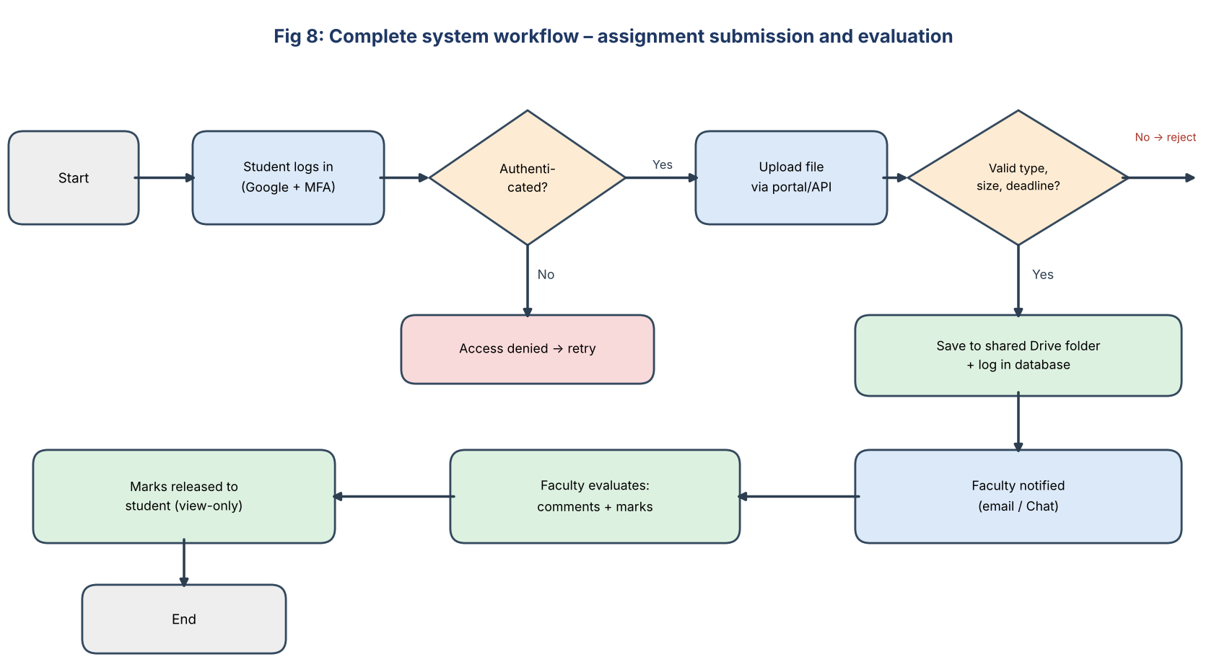
Fig 8: Complete system workflow

Stage 4 – Validation

Student A – Technical Validation
Cloud access method: browser/mobile app over HTTPS, as no installation is needed and all students own smartphones/laptops; API is used internally between portal and Drive. Platform justification: Google Workspace provides ready storage, real-time collaboration and identity; Google Cloud Run offers scalable, pay-per-use hosting for the API – lowers cost and development time. Architecture: clients → Internet → portal/API (validation, authentication) → Drive/Sheets (shared resources); security and collaboration layers cut across all tiers. API use: the portal calls the Drive API (upload, set permissions) and Sheets API (log submission) using OAuth tokens. Suitability: scalable for hundreds of students, accessible, secure, low cost; suitable where Internet is available.

Student B – Experimental Validation
TC | Test case / user & condition | Expected behaviour | Observed | Result
1 | Student logs in with valid credentials + OTP | Access granted | Dashboard opened | Pass
2 | Wrong password / no OTP | Access denied | Login rejected | Pass
3 | Student uploads PDF before deadline | File stored, notification sent | Saved in Drive; faculty notified | Pass
4 | Upload .exe file / after deadline | Rejected with message | Error message shown | Pass
5 | Faculty adds comment and marks | Visible to student, file not editable | Comment visible; edit blocked | Pass
6 | Student tries to open another student’s folder | Access denied | “You need access” | Pass
7 | Upload from mobile on 4G vs laptop on Wi-Fi | Works on both; slower on 4G | Works; 4G upload slower | Pass
8 | Two students co-edit group Doc | Real-time sync | Updates in seconds | Pass
Expected vs observed: all test cases matched expected behaviour; the only deviation was slower upload on mobile data, confirming the dependence on network quality.

Stage 5 – Cross-Defence
Student A – experimental evidence supporting the design: successful login with MFA and rejection of invalid login (authentication works); upload restrictions on file type/deadline (API validation works); access denied to other students’ folders and view-only marks (authorization works); real-time co-editing and version history (collaboration works); working access from both laptop and mobile (accessibility). Together these show that the design meets the requirements.
Student B – why this access and collaboration approach was chosen: browser/mobile access is platform independent and needs no installation; Google Drive/Docs give proven real-time collaboration, version control and permission management without building everything from scratch; the portal/API adds the validation and automation the college needs; cloud scalability suits peak load near deadlines; and the approach combines the strengths of both initial proposals.

Stage 6 – Joint Evaluation
Aspect | Evaluation
Benefits | Paperless, anytime submission, faster evaluation, automatic records, reduced loss and cost
Access-related limitations | Needs Internet; low bandwidth slows uploads; users without devices; dependence on provider availability
Collaboration benefits | One shared copy, real-time co-editing, comments, version history, transparent feedback
Security risks | Credential theft, wrong permissions, data leak, plagiarism/tampering, provider outage – reduced by MFA, RBAC, TLS, audit logs, backups
Scalability | Cloud Run/Drive scale automatically with number of users; quota and cost monitoring needed
Possible improvements | Plagiarism checker, auto notifications/reminders, offline mode, analytics dashboard, SSO with college accounts, multi-region backup
When not appropriate | Areas without reliable Internet, highly confidential/regulated exams or data that must stay on-premises, strict offline requirement, when budget/vendor lock-in is a concern

Final Question – Characteristics a designer should consider before selecting cloud-based access and collaboration
- Requirements and users: number of users, roles, devices and locations.
- Connectivity: availability, bandwidth and latency of the network; need for offline work.
- Security and privacy: sensitivity of data, authentication, authorization, encryption, legal/compliance rules (data location).
- Reliability and availability: provider SLA, backup, disaster recovery.
- Scalability and performance: expected growth and peak load.
- Cost: subscription, storage, bandwidth, vendor lock-in versus on-premises cost.
- Collaboration needs: concurrent editing, version control, permission granularity.
- Integration: APIs and compatibility with existing systems and standards.
- Usability and training: ease of use for all users.
- Control and support: data ownership, portability, exit strategy and vendor support.

